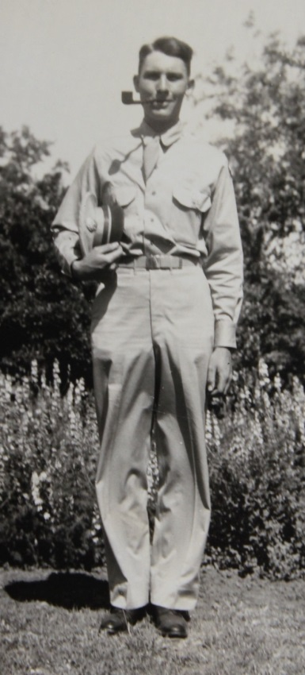

**Roger Earl Wolfe – about 1944**

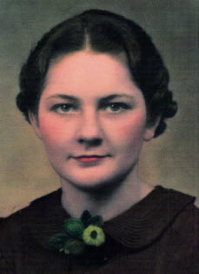

**Jessie Rosealtha Dresbach Wolfe**

**Photo taken about 1936**